CS**1180 Project 6**

**Purpose:** For the final project this semester, you will create a program with a graphical user interface. The task of the program is of your own choosing, but it must meet the minimum requirements listed below. You may find ideas for possible projects in your textbook (look at the end of each of the chapters on JavaFX). Not all the problems in those chapters will meet the minimum requirements, so choose carefully. You may also choose to re-do a previous project using a graphical user interface, but you may need to extend the functionality to meet all the requirements of this project.

**Minimum requirements:**

1. at least one text field for input. Erroneous input (missing input, wrong data type, out of range) must be handled so program doesn’t “crash.”
2. a way for the user to make selections (radio buttons, checkboxes, combo box, menu items, etc.)
3. at least three listeners for event handling (one for item 1, one for item 2, possibly a third with the animation)
4. a label, text field, text area, or other output
5. an animation
6. You must code the interface “by hand”. You will not receive any credit if you use any drag-and-drop tool for creating GUIs.
7. WOW points. Including all of the items listed above will, at most, earn 90% of the possible points for this project. You will need to go above and beyond to earn the other 10%.

The following screen shot illustrates one possible project that meets and exceeds the above requirements. The animation in the right pane is bouncing ball that is in continuous motion. The controls in the left pane affect the animation in the right pane. The size and color of the ball can be changed. The color of the background of the right pane can be changed. Colors are selected from combo boxes with a specific list of colors. The speed at which the ball moves can be changed to increase or decrease the rate in either the X or Y direction.

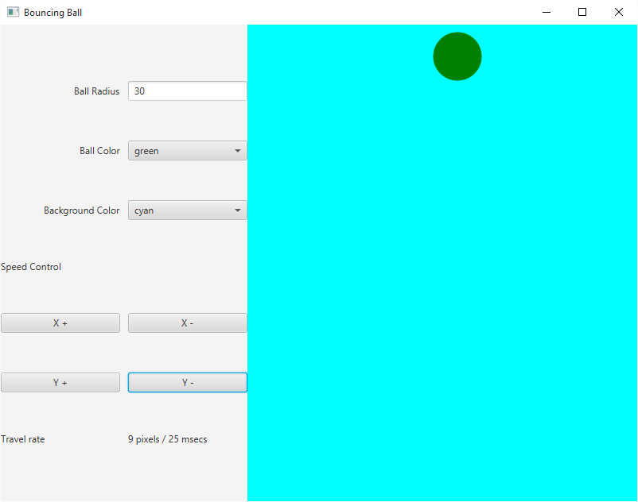

**Submit a separate text file containing a copy of your source code. Submit a ZIP file containing your entire Netbeans project.**

**If your program does not compile OR you fail to submit a separate text file you will receive a zero for the project.** **You will not receive any credit if you use any drag-and-drop tool for creating GUIs.**

**Rubric (100 pts)**

* at least one text field that handles user input with error handling for incorrect input(10 pts)
* a way for the user to make selections (radio buttons, checkboxes, combo box, menu items, etc.) (15 pts)
* at least three listeners for event handling – program responds to user selections and inputs (20 pts)
* a label, text field, text area, or other output – program displays some meaningful output (15 pts)
* an animation which works (20 pts)
* WOW points. (10 pts).
* Code follows style requirements with respect to commenting all classes and methods, naming of identifiers, use of braces, indenting, etc. (10 points)